1. **When you run/create any container then it by default use or connected by bridge network.**

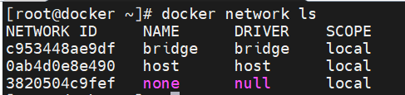

**#docker network inspect bridge**

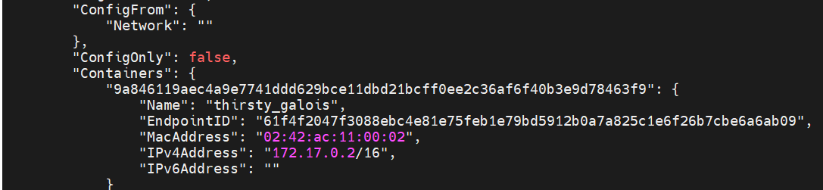

1. **How to create your own bridge network**

**#docker network create -d bridge test**

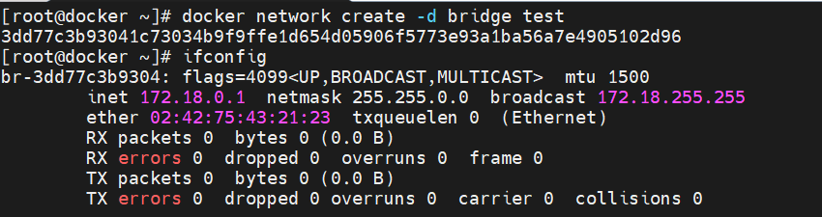

1. **How to create container with specific network**

**#docker container run -it --network test ubuntu:22.04 bash**

1. **Ifconfig command output displays the container network details and to which bridge it is connected. i.e default docker bridge or if you have created any own bridge network.**
2. **If you create your custom network then DNS is default enabled in it so you can ping with other container (with their hostname) which is running under that custom network. Please note that in default network DNS is not enabled.**
3. **You can create only one container with host network. Because, host network uses same network of your server on which docker is installed. So while using host network your container services are isolated except network. On other hand, while using bridge network all services is isolated including network.**
4. **Null network is used to create such container where ip is not required i.e. no network. Only loopback interface will be present.**
5. **You can connect/disconnect additional network to your container.**

**#docker network connect test 415d2421827b**

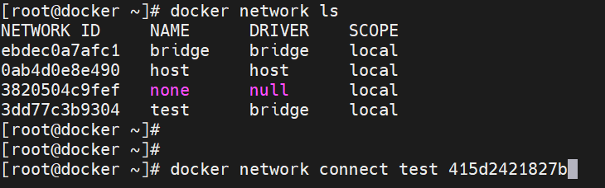

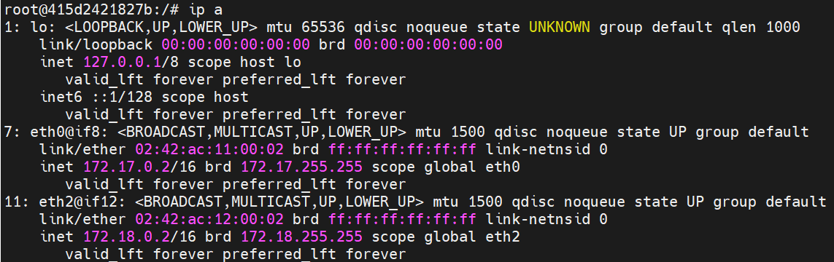

**To disconnect,**

**#docker network disconnect test 415d2421827b**

1. **To remove network**

**#docker network rm test**

1. **To remove all unused network**

**#docker network prune**